CMP 2004 Term Project Report Template (JAVA SHOOTİNG GAME)

Oğuz Şekerci 1242464

Görkem Kuvancı 1185640

# Explaın your project Purpose

The aim of this project was to make a shooting game using 2D graphics. Based on the information we have learned that we wanted to show 2D graphics make a game and putting forth our information revealed in this way we have a project. In the given scenario, and we have tried to make the most appropriate manner in line.

# Explaın Your Project Code (Mınımum Crıterıa)

Starting first as " Enemy " class and the " Player " class have created . These objects play in our player and the enemy has enabled us to create . Player and enemy have created a 2D shape as a rectangle . Then our enemy bullets , allowing us to shoot in class again have created a rectangle with the class . We then provide it to kill enemies " intersects " function 've assigned . Again, in the continuation of this function ensures that we give 100 points when each enemy killed . And an increase of 1 of every 1000 points you 've set in the heart of the enemy . Then, to ensure that the movement of the characters "move" functions have created . Seduce the enemy 's coming from a place above random and shot down if the player can die if hit from the first point to make is düşüyor.eg disappears and re- set the random have to come from somewhere . 0 if the player can of course finalizing our game "Game Over" brought entry . Then again, the enemies within the class file of the highest scores in reading and high scores to write a reader and writer functions we 've written course it on the home screen we get name and surname I have also added and where the highest score to keep 've provided . When we came to the class of player the user can play them again for our players we create a rectangle with the class " KeyListener " by using the arrow keys to move provides our users , and we have it with a screen size limit . And immediately place here , and we set the shape of our bullets .

Startpanel is in a class of our game we have created a panel to create a splash screen and more into it, we have created two separate panels including 've added to the lower left to lower right . If we lower left to lower right button and checkbox label have added high score . Buttons and labels , and others added to the panel in the normal way . Save and load our button " ActionListener " functions to read and write to the file with the file 've assigned functions .

Maine is in a class of our yarn and create the main functions of our game, and we have created our screen . Random objects and other enemies we have created our objects . The main function of which we are part of the game screen frame section. Run some parts of our yarns to work . Stop when finished our game that keeps fonsiyonu part.

And the real main, which is our "RealDealMain" In our class , and create counter this "switch" have provided tossing them into the transition between screens . At first , our home screen, then our game screen . In the end, "Game over" writing and the writing score will allow us to push through java chart we created our functions .

# Screenshots

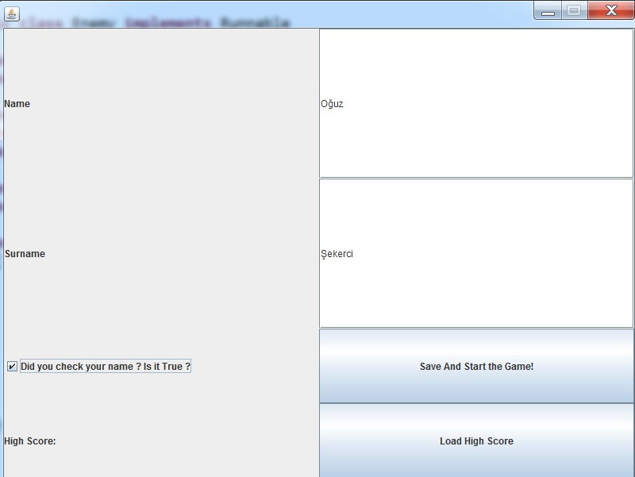

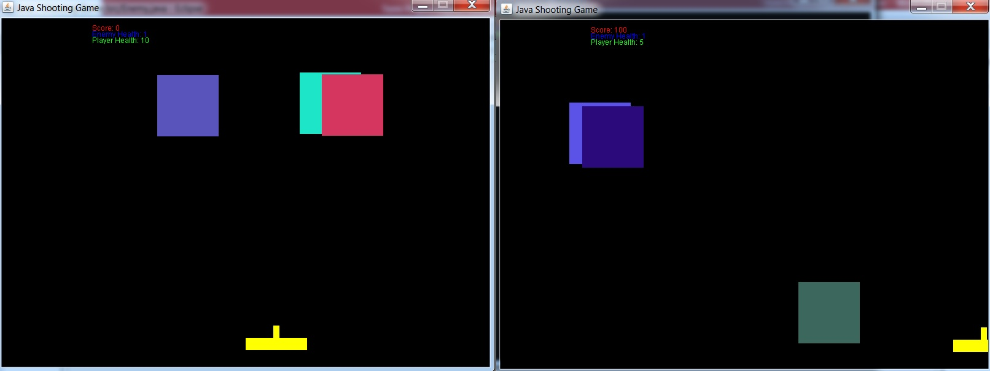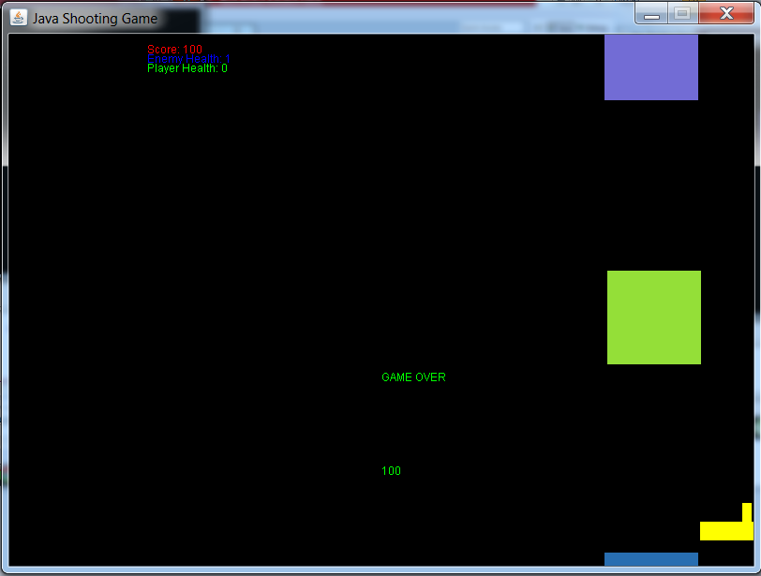

# Extra Informatıon

Contained in our program "wallpaper.jpg" file, despite all our efforts we could not add to the background of our game.